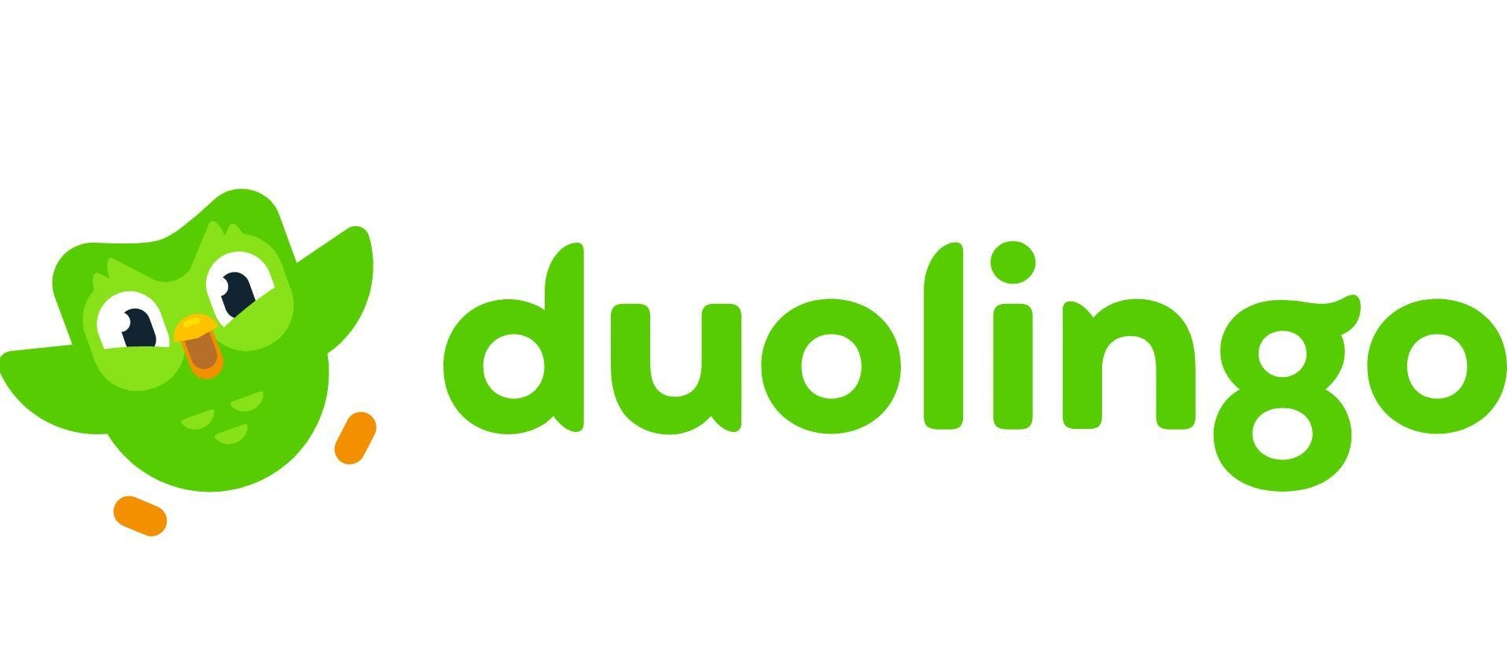

# **DUOLINGO USER INSIGHTS**

# **AND**

# **PERSONALIZED RECAP DASHBOARD**

1. **INTRODUCTION:**
   1. **About Duolingo**

Duolingo is a popular language-learning app that offers free, gamified lessons in multiple languages. It uses interactive exercises, AI-driven personalization, and a streak system to keep users engaged. The app covers reading, writing, speaking, and listening skills through bite-sized lessons. Duolingo also provides premium features with Duolingo Plus, offering an ad-free experience and offline access. Its mascot, Duo the owl, motivates users with reminders and challenges. With millions of learners worldwide, Duolingo makes language learning fun and accessible to all.

* 1. **Problem Statement**

Duolingo plans to introduce new features to enhance learning engagement by analyzing user progress and learning patterns. The goal is to improve overall platform interaction and learning success rates. One such feature, **"Week in Review,"** will highlight key user insights and compare them to broader platform trends. Similar to Spotify’s or YouTube’s **"Year in Review,"** it will provide a personalized summary of user activity and achievements.

* + 1. **Tasks:**
* ***Analyse overall user data (EDA) to find trends and behaviour patterns and suggest improvements to make the platform better and explain why.***
* ***Create a personalized recap for the most engaged user (the user who is most active on the platform) by comparing their performance to overall platform trends and sharing their overall metrics.***
  + 1. **Goals:**

To uncover insights that will:

* ***Help Duolingo improve its strategies to keep users engaged and learning.***
* ***Provide users with a fun, personalised recap to make learning more rewarding and engaging.***
  1. Dataset Overview